**Earnings and Expenses Tracker**

**Introduction**

As we know with the busy schedule it is often hard to keep track of expenses and it is more likely we don’t remember the small expenses. Especially for travelling business person it very important to remember all the expenses and file those expenses to the company as most of the companies reimburse the expenses for travelling, food, hotel etc. Not only for the travelling person it is very difficult to remember the small expenses even for the normal person.

We can easily manage the budget if we can keep track of the various expenses and the earnings from multiple sources. This app will help the users manage their expenses in a better way as they can enter the earnings, Personal expenses and business expenses at the same place. The app can be further developed to integrate with the company expense upload system and directly upload the expenses to the companies expense portals.

**PROJECT OVERVIEW**

The app will enable the user to capture both the earnings and expenses. The user can register for the app by using the Sign up feature and the user can even login using the GOOGLE Sign In. Additionally, the user authentication is enabled using the FIREBASE AUTHENTICATION. Once the user log into the application the user details are stored in the FIREBASE DATABASE. The sign out feature will enable the user to securely logout of the app.

While capturing the earnings the user will be able to customize the app by adding the sources of income as each user may different sources of income. The user will be able to view all the earnings from different sources (for eg: Income from Salary, Income from business, Property Income, etc). The user will be able record all the earnings from the sources he would like to enter. Similarly, user can enter expenses for Personal and Business. The personal expense is further categorized as expenses for Shopping, Gas, Entertainment, Groceries, etc). The Business expense is further categorized into Travel, Food, Hotel and Others.

Apart from adding and view all the earnings and expenses, the user can scan the receipt (for eg: grocery store receipt) and the data is extracted from the image. The user can add the expense from the receipt and share using the Activity indicator. I have used TESSERACT OCR framework for the smart scan feature. The user can view all the expenses for Personal and Business categories. The user can update his profile information and change the profile picture. The images and receipts are stored in the FIREBASE STORAGE.

**TOOLS AND ADDITIONAL FEATURES**

FIREBASE AUTHENTICATION

GOOGLE SIGN IN

FIREBASE DATABASE

FIREBASE STORAGE

TESSERACT OCR FRAMEWORK

CORE IMAGE FRAMEWORK

MESSAGE UI FRAMEWORK

ACTIVITY CONTROLLER

ACTION SHEET

**FEATURES**

SIGN IN:

The user can Sign in if he is already registered user. The user can sign up if he is a new user. Also the user can use Google Sign in feature to login using Google account.

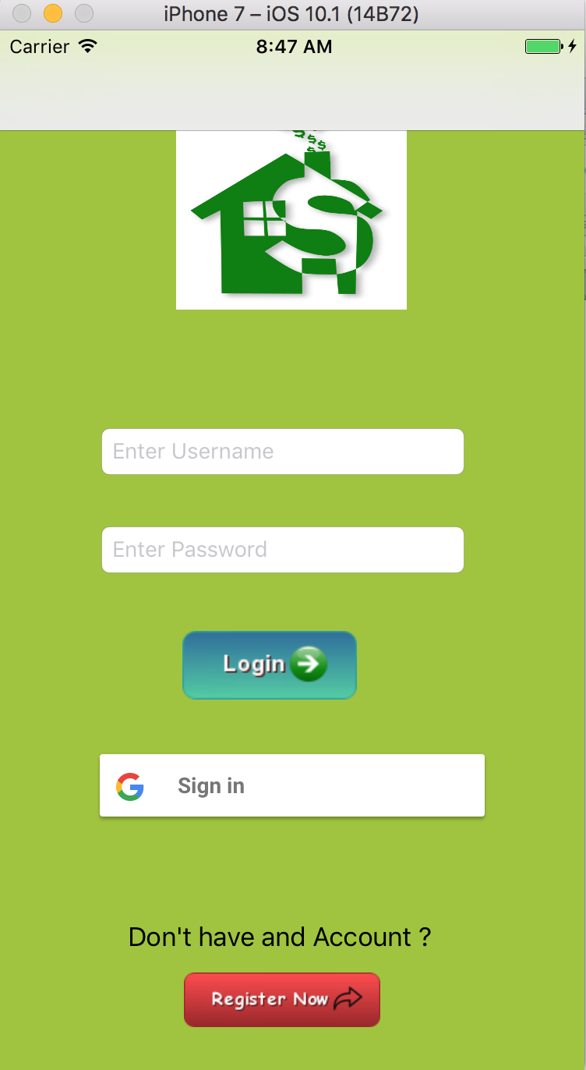

Sign Up:

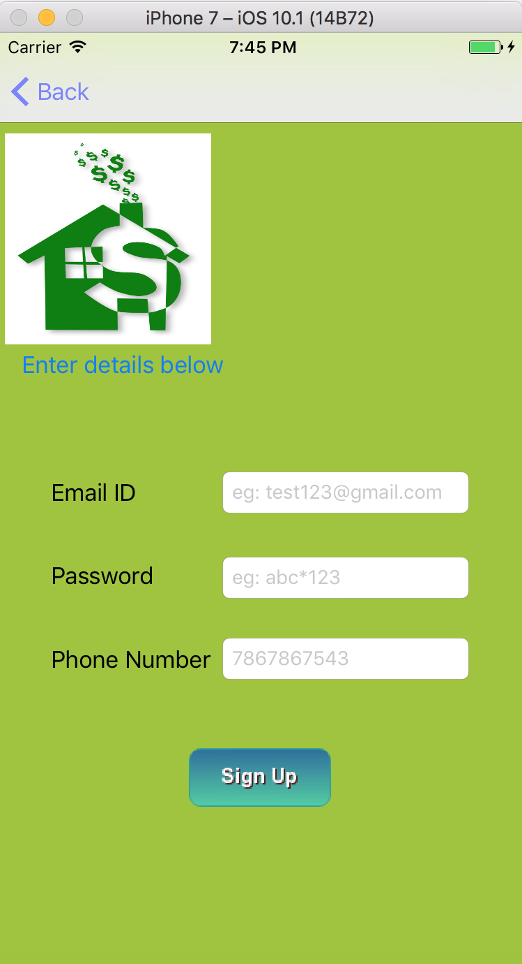

Google SignIn

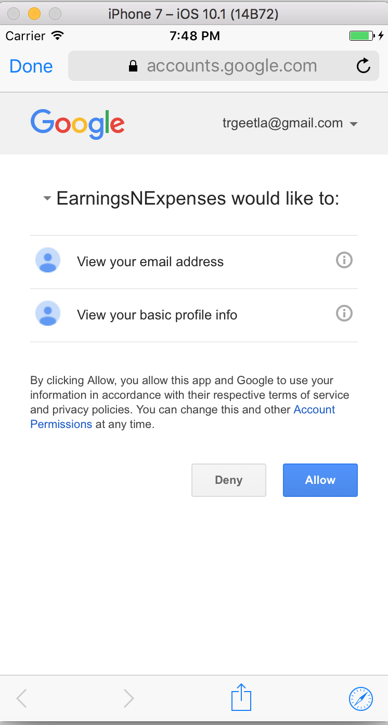

Home Page With Sign out Feature.

After logging the home page is displayed.

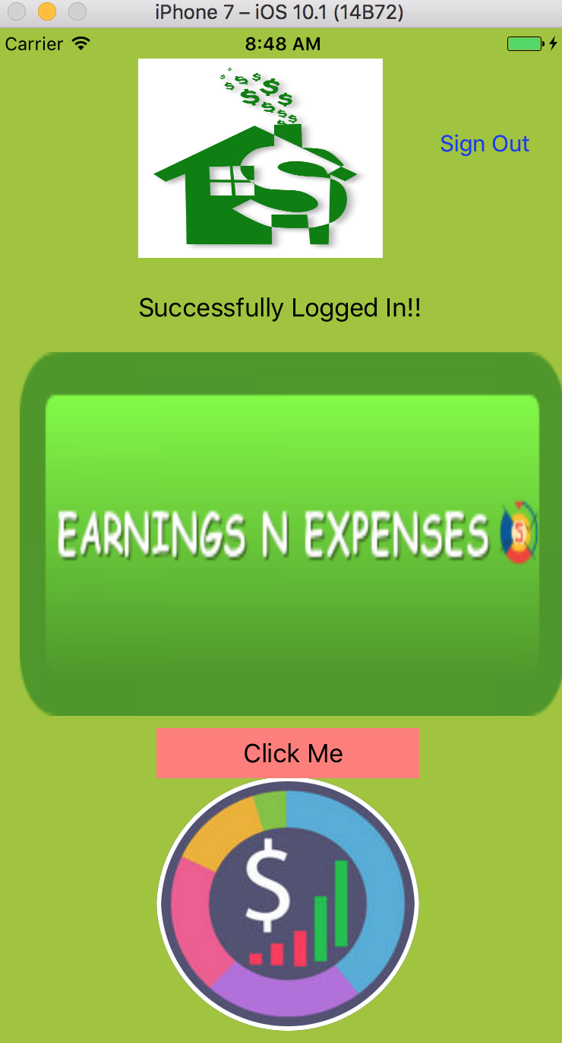

Once the user clicks on the Click me image the user is taken to the next page with the Tab bar Controller. The app has multiple tabs like Earnings, Expenses and Profile tab. The app can be extended further by adding new tab to the tab bar controller.

The first shown to the user is Profile tab where the user can update Profile and add profile picture.

Update Profile:

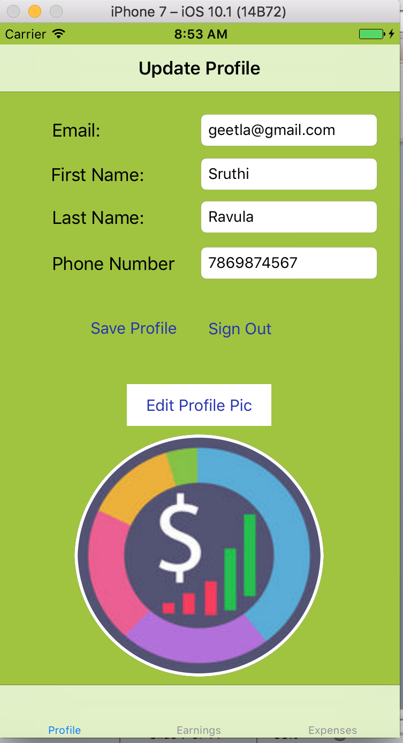

The user can update Profile picture:

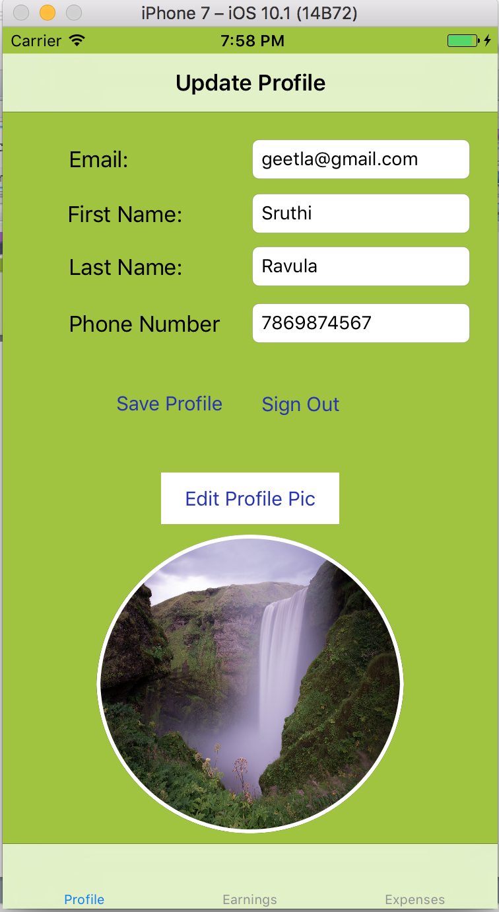

Earnings:

The user can click on the earnings tab to add source of Income and capture earnings

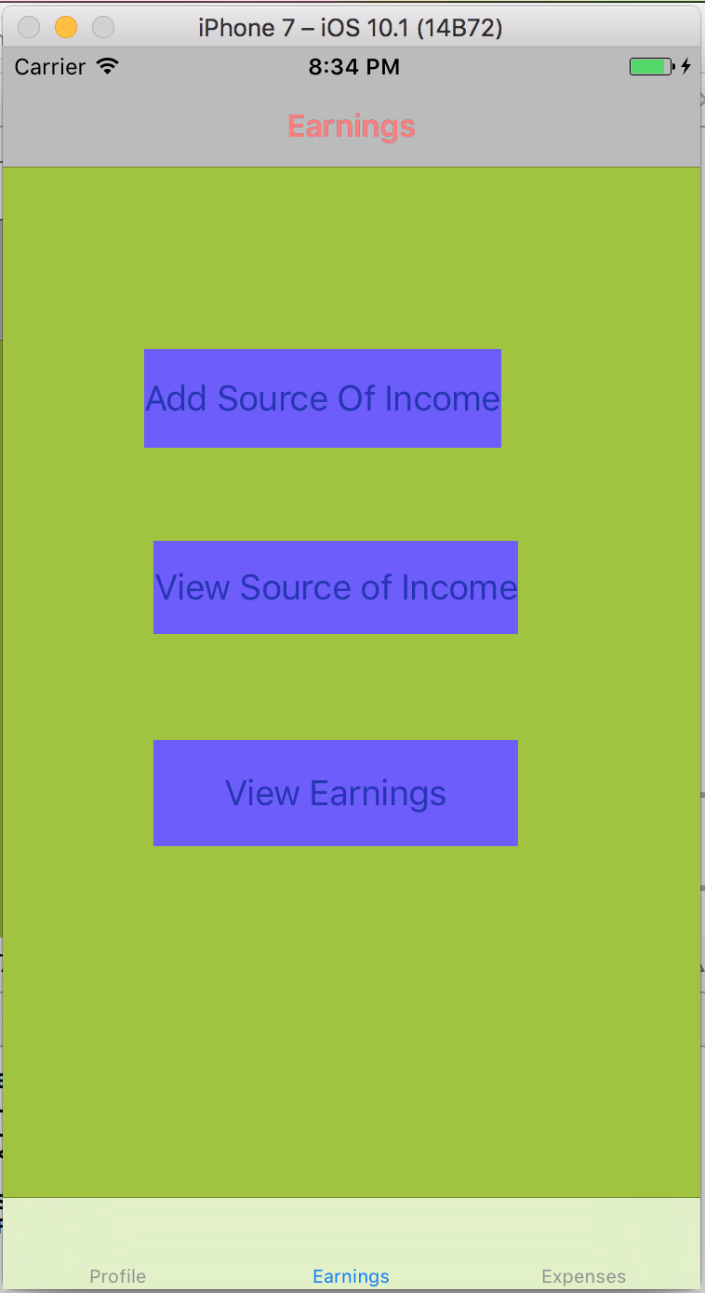

The user can customize the app by entering the sources of Income he want to add.

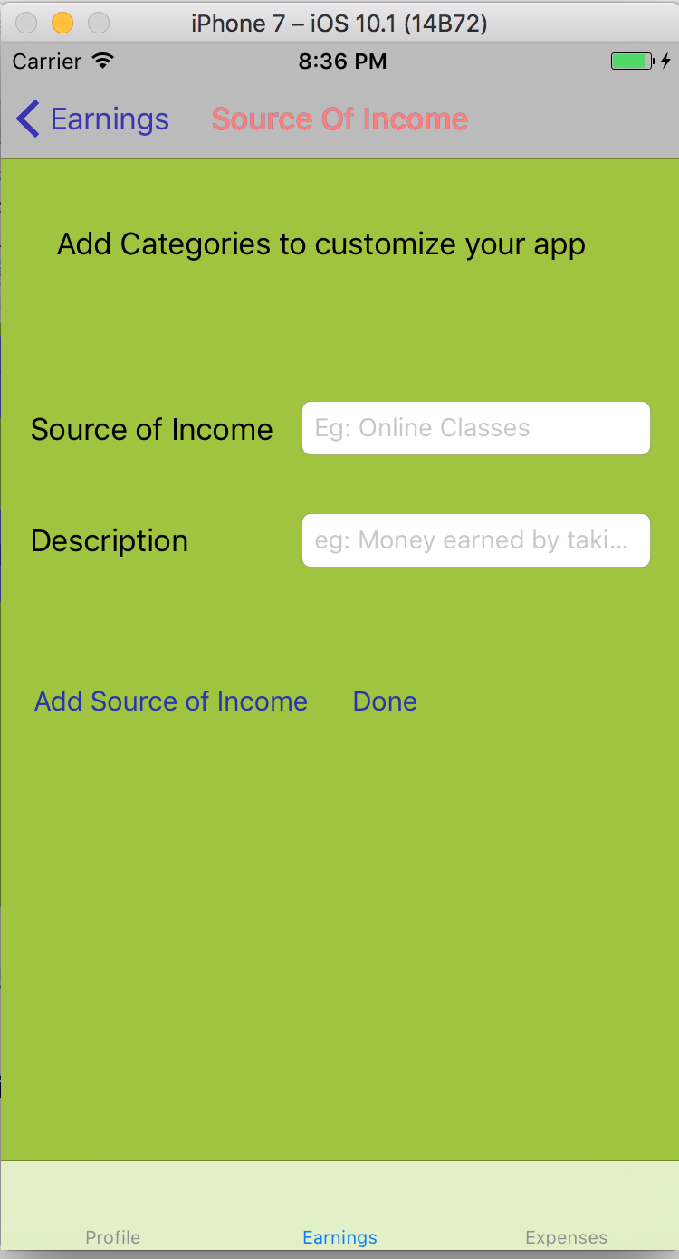

View Sources of Income added by the User:

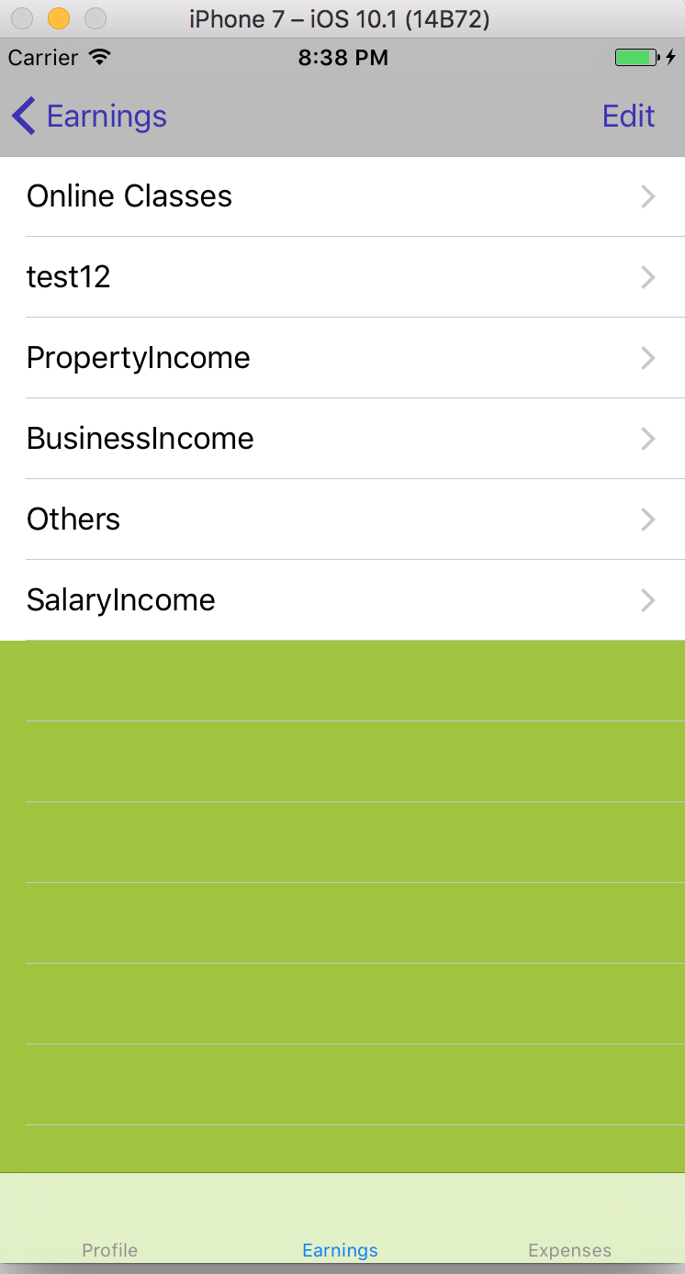

The User can enter the amount earned by each of the sources by Clicking on the table view cell. I used date picker for user to enter the date.

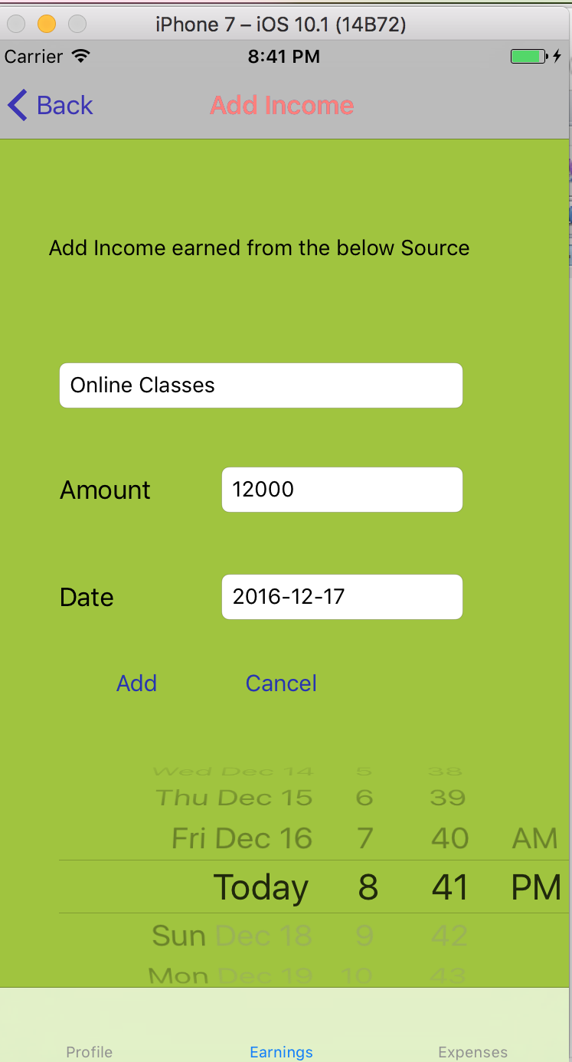

View Earnings

The user can view the total amount earned

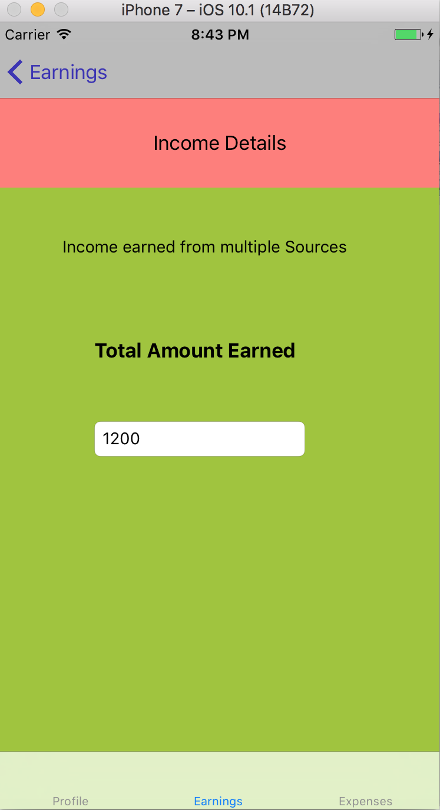

Expenses:

The user can click on the expenses tab to record the expenses.

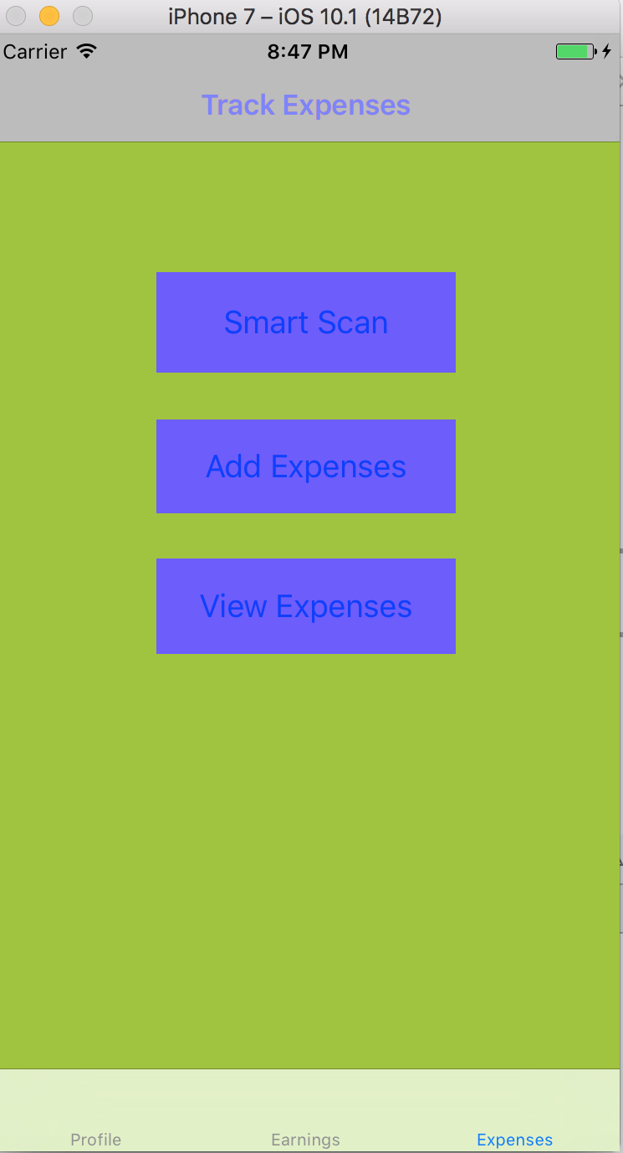

The user can scan the receipt by clicking on the Smart scan. The user can also add the expenses by clicking on Add Expenses button.

Smart Scan:

I used Tesseract OCR Framework to enable the smart scan and recognize the text in the image. I used English language training data. We can also add other language training data and read the receipt in other languages as well.

The framework is added along with other frameworks like Core Image Framework and Message UI Framework

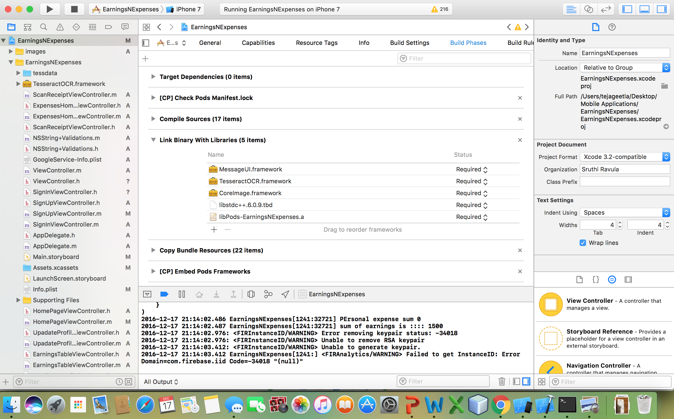

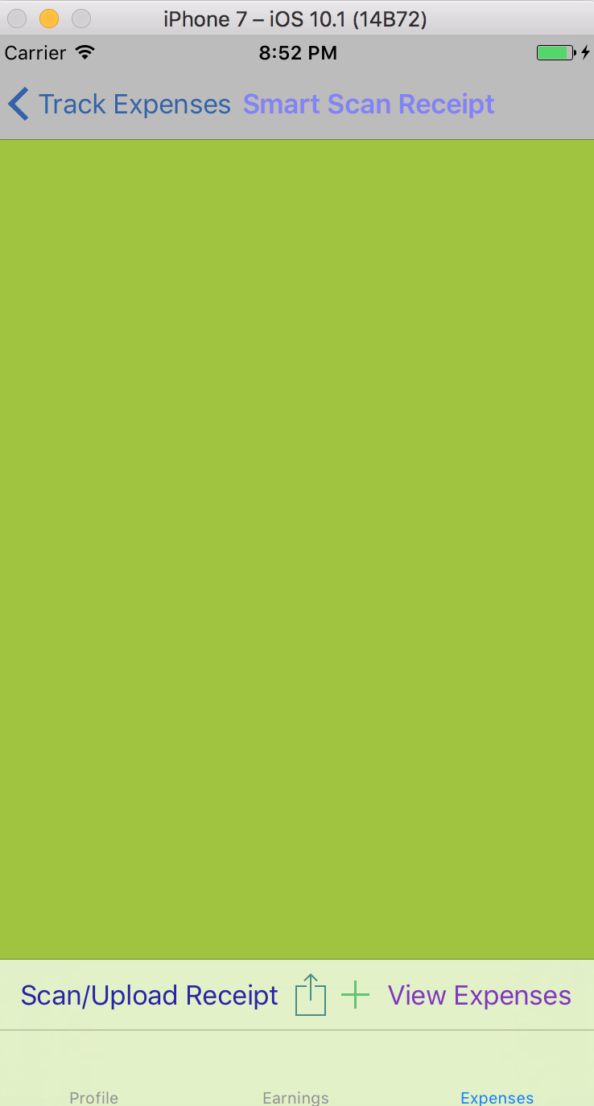

The user can perform multiple actions by scanning the receipt, sharing using activity controller, adding the expense and view the expenses.

Scan/Upload Receipt

In the phone the user can take picture but due to constraints on using a simulator the user can select a picture from the photo video library.

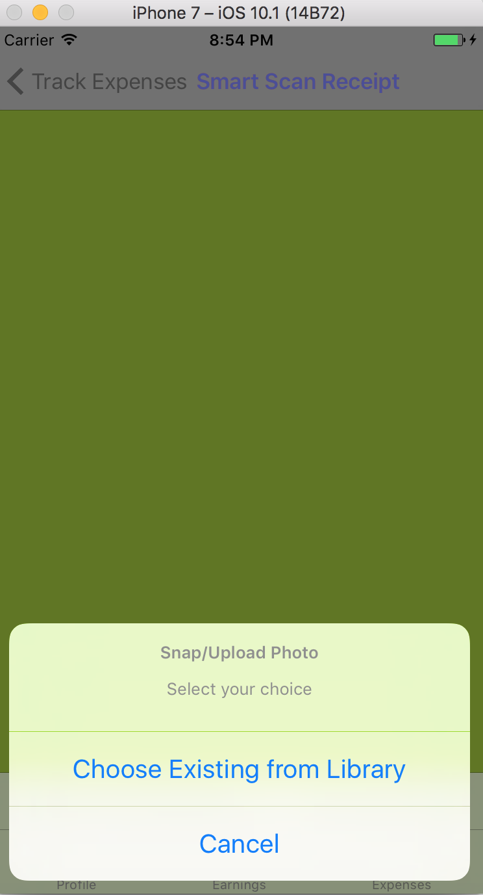

The user can scale the image and select the image he want to upload.

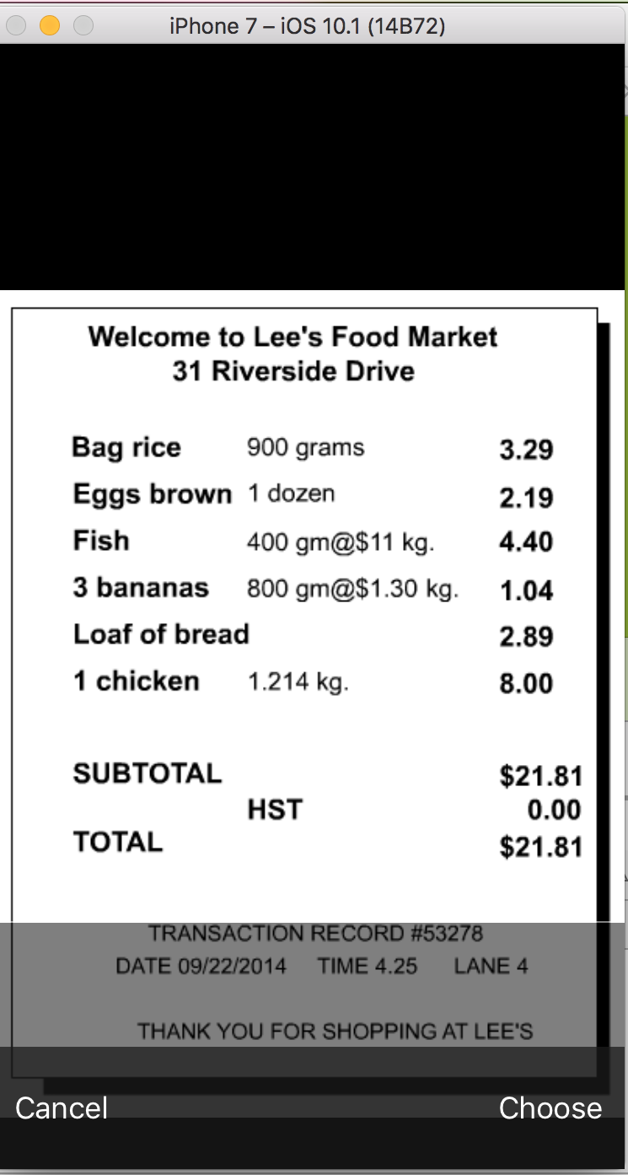

The user can see the extracted text in the UI text view.

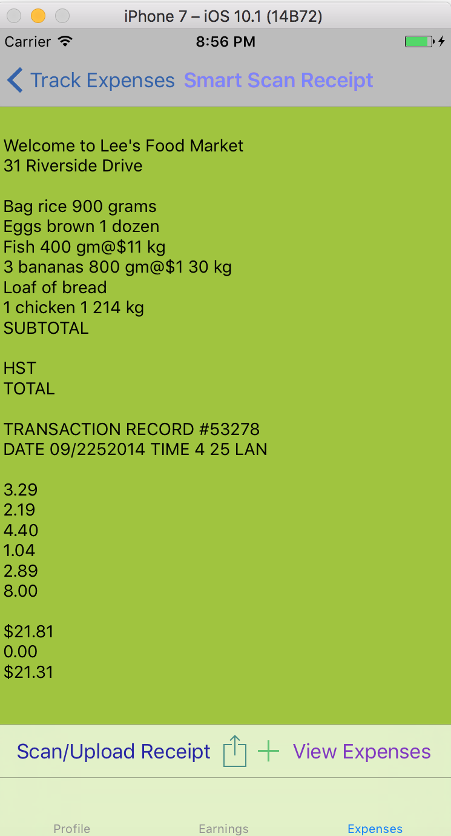

The user can copy the text by using the share image on the Tool bar

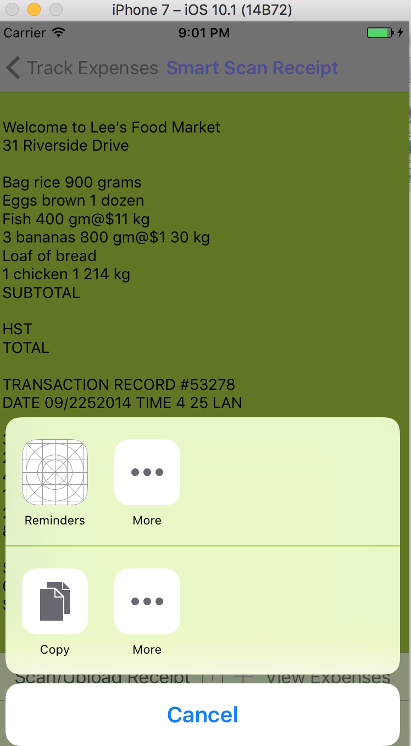

The user can add expenses by clicking on the plus button on the tool bar. The user can also enter the expenses manually by clicking on the Add expenses button in the Expenses Tab.

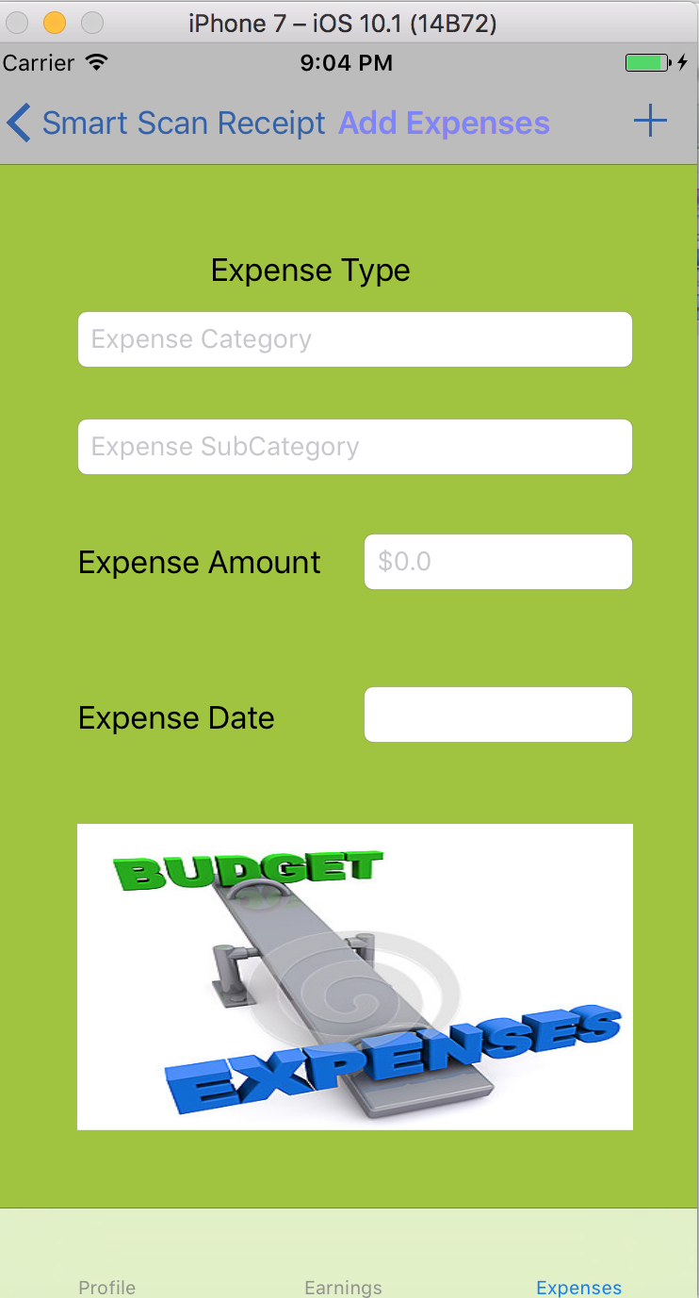

The user can select the category they would like to enter the expenses. I used Action Sheets to display various category options. If the user selects Personal then a set of sub categories is displayed. If user clicks on Business different set of sub categories is displayed.

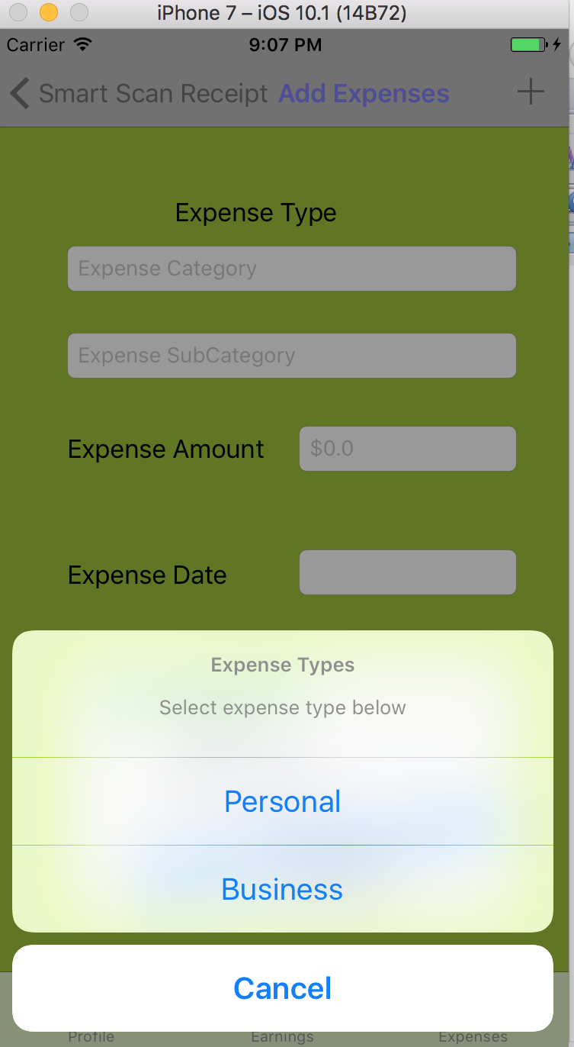

User Selects Personal Category

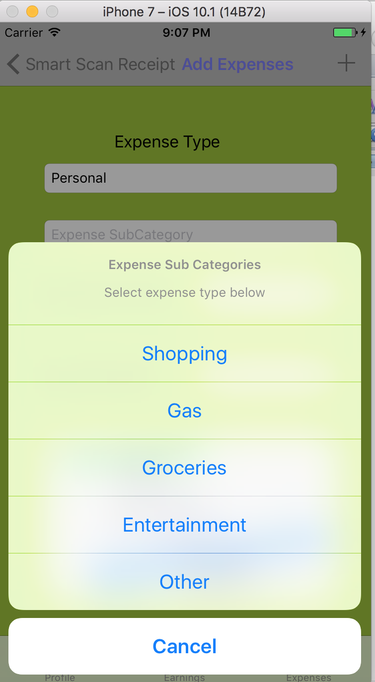

User selects business category

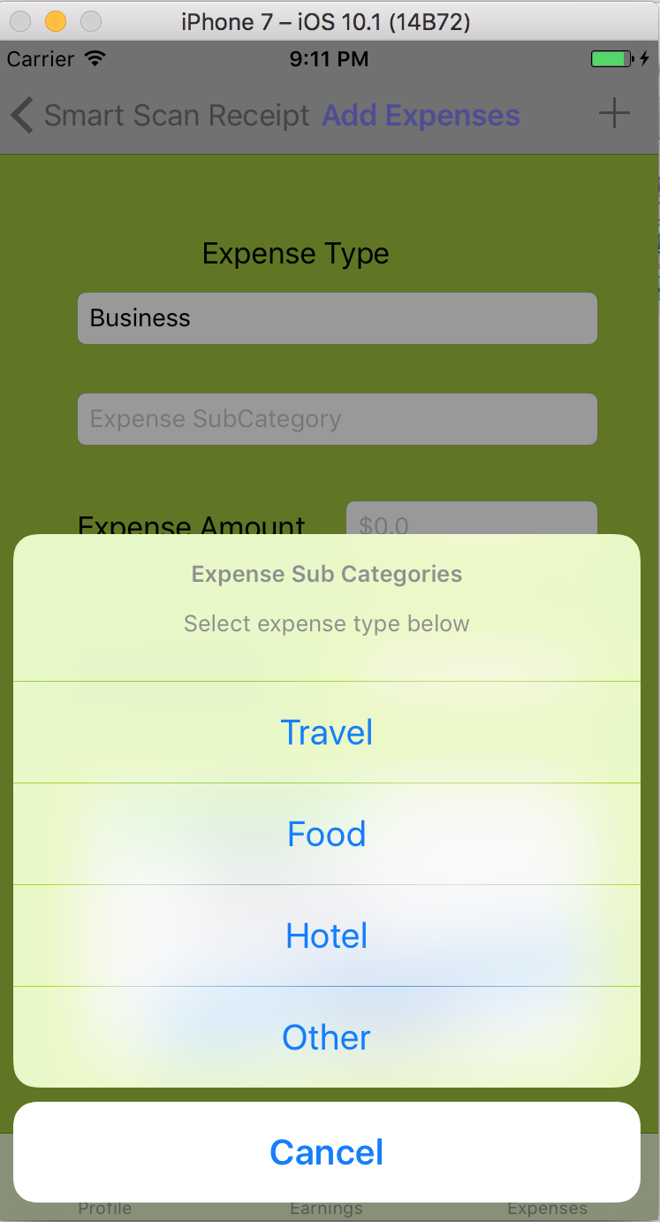

View Expenses

The user can view total expenses in Personal and Business.

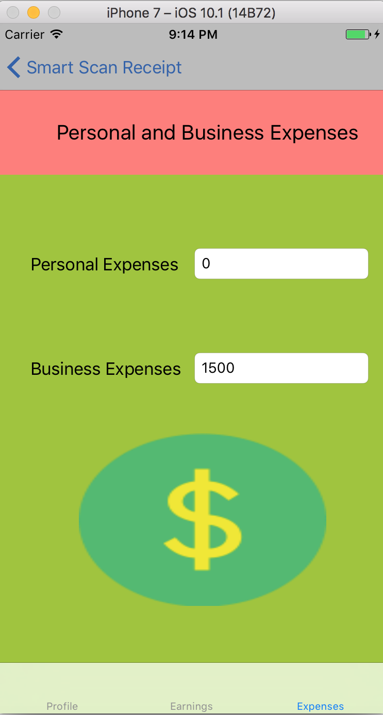

**FIREBASE**

Used Firebase Authentication, Firebase Database and Firebase Storage:

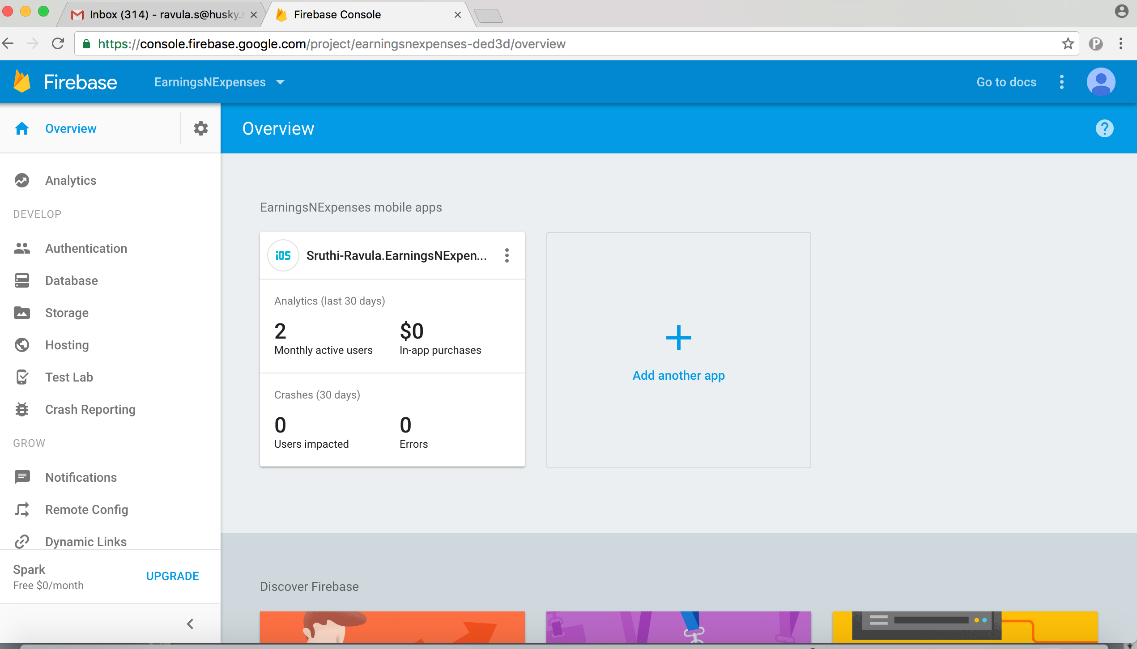

Below is the list of authenticated users.

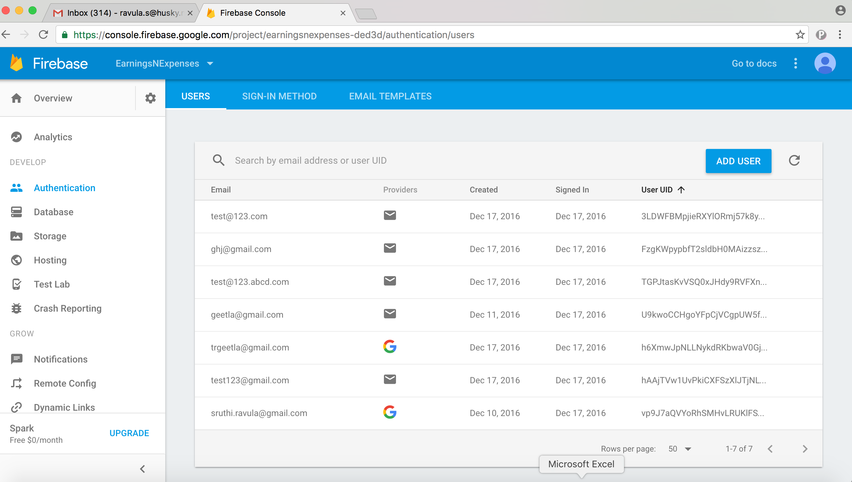

FIREBASE DATABASE

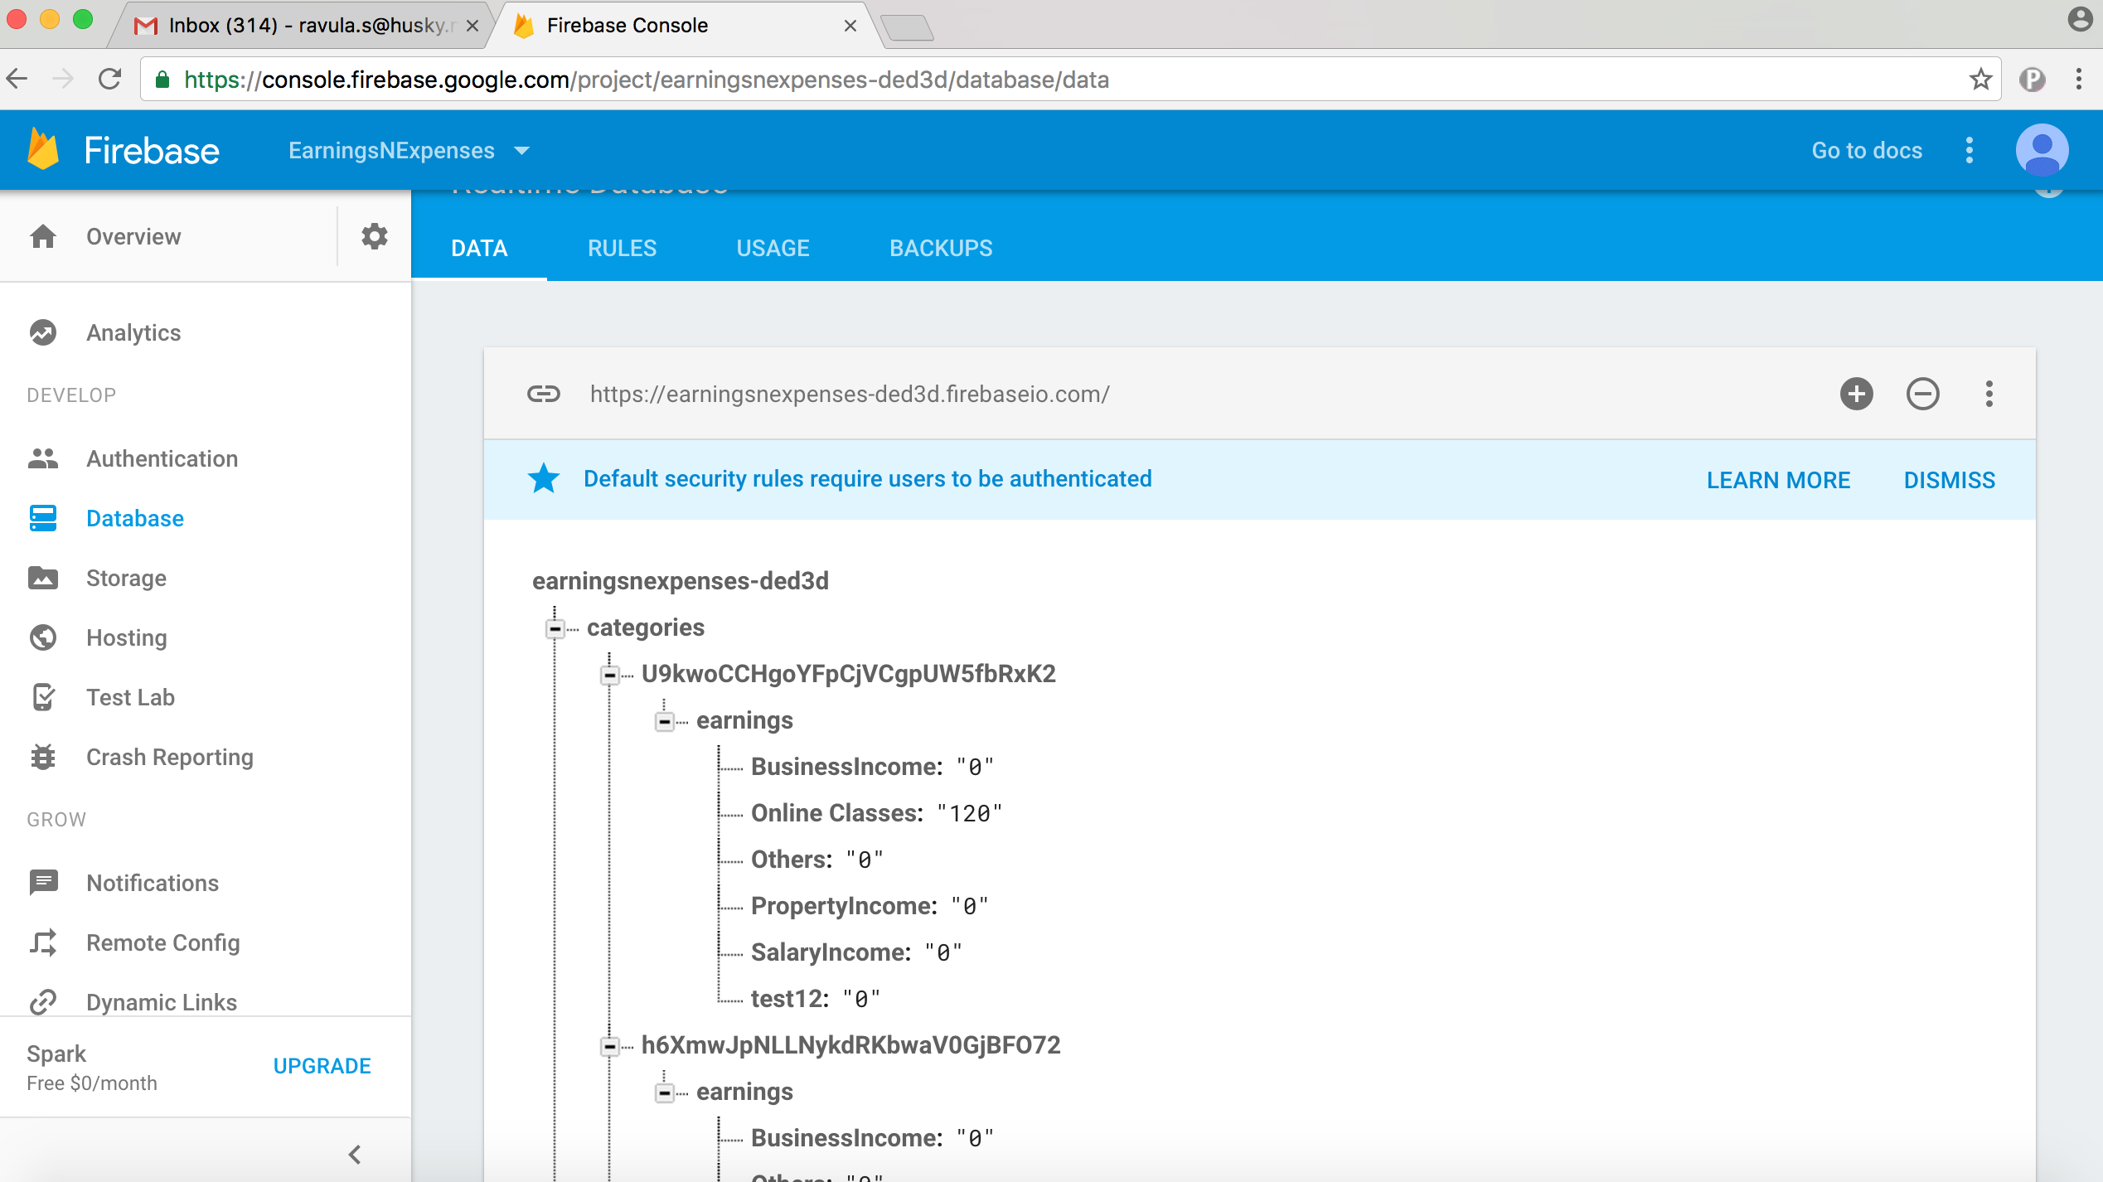

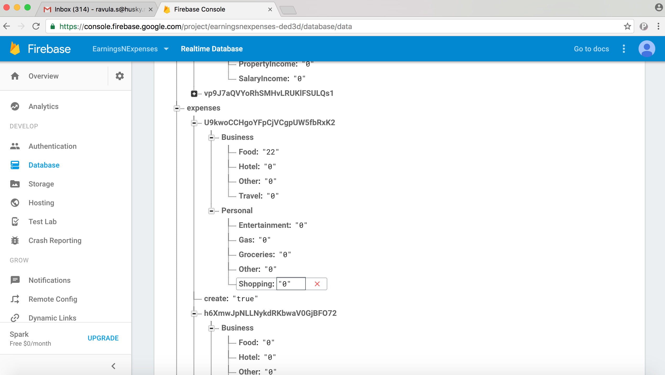

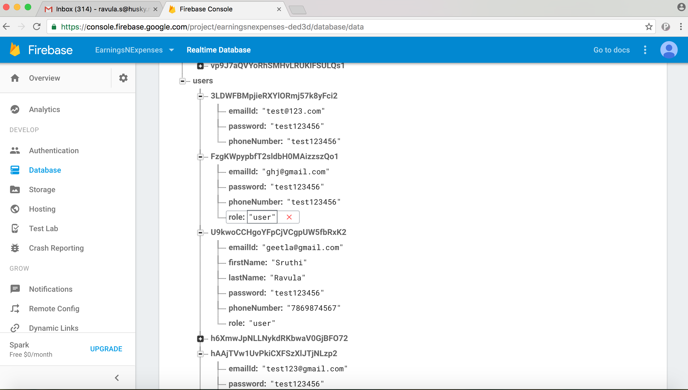

FIREBASE STORAGE:

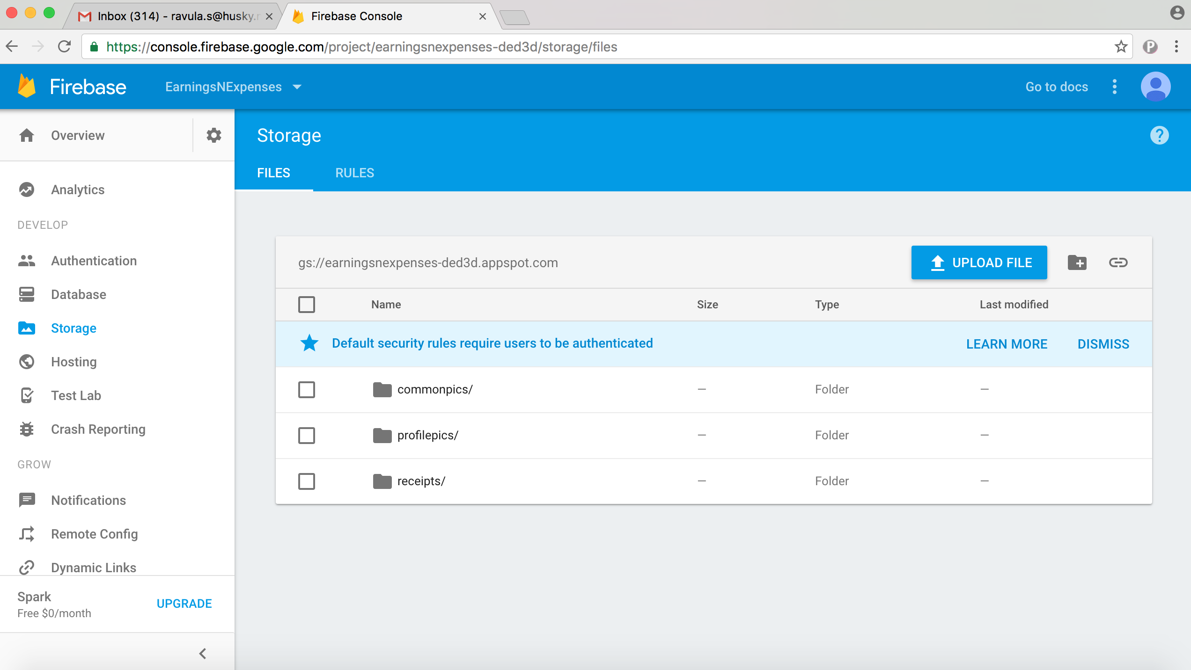

Scanned Receipts are stored in the receipts folder

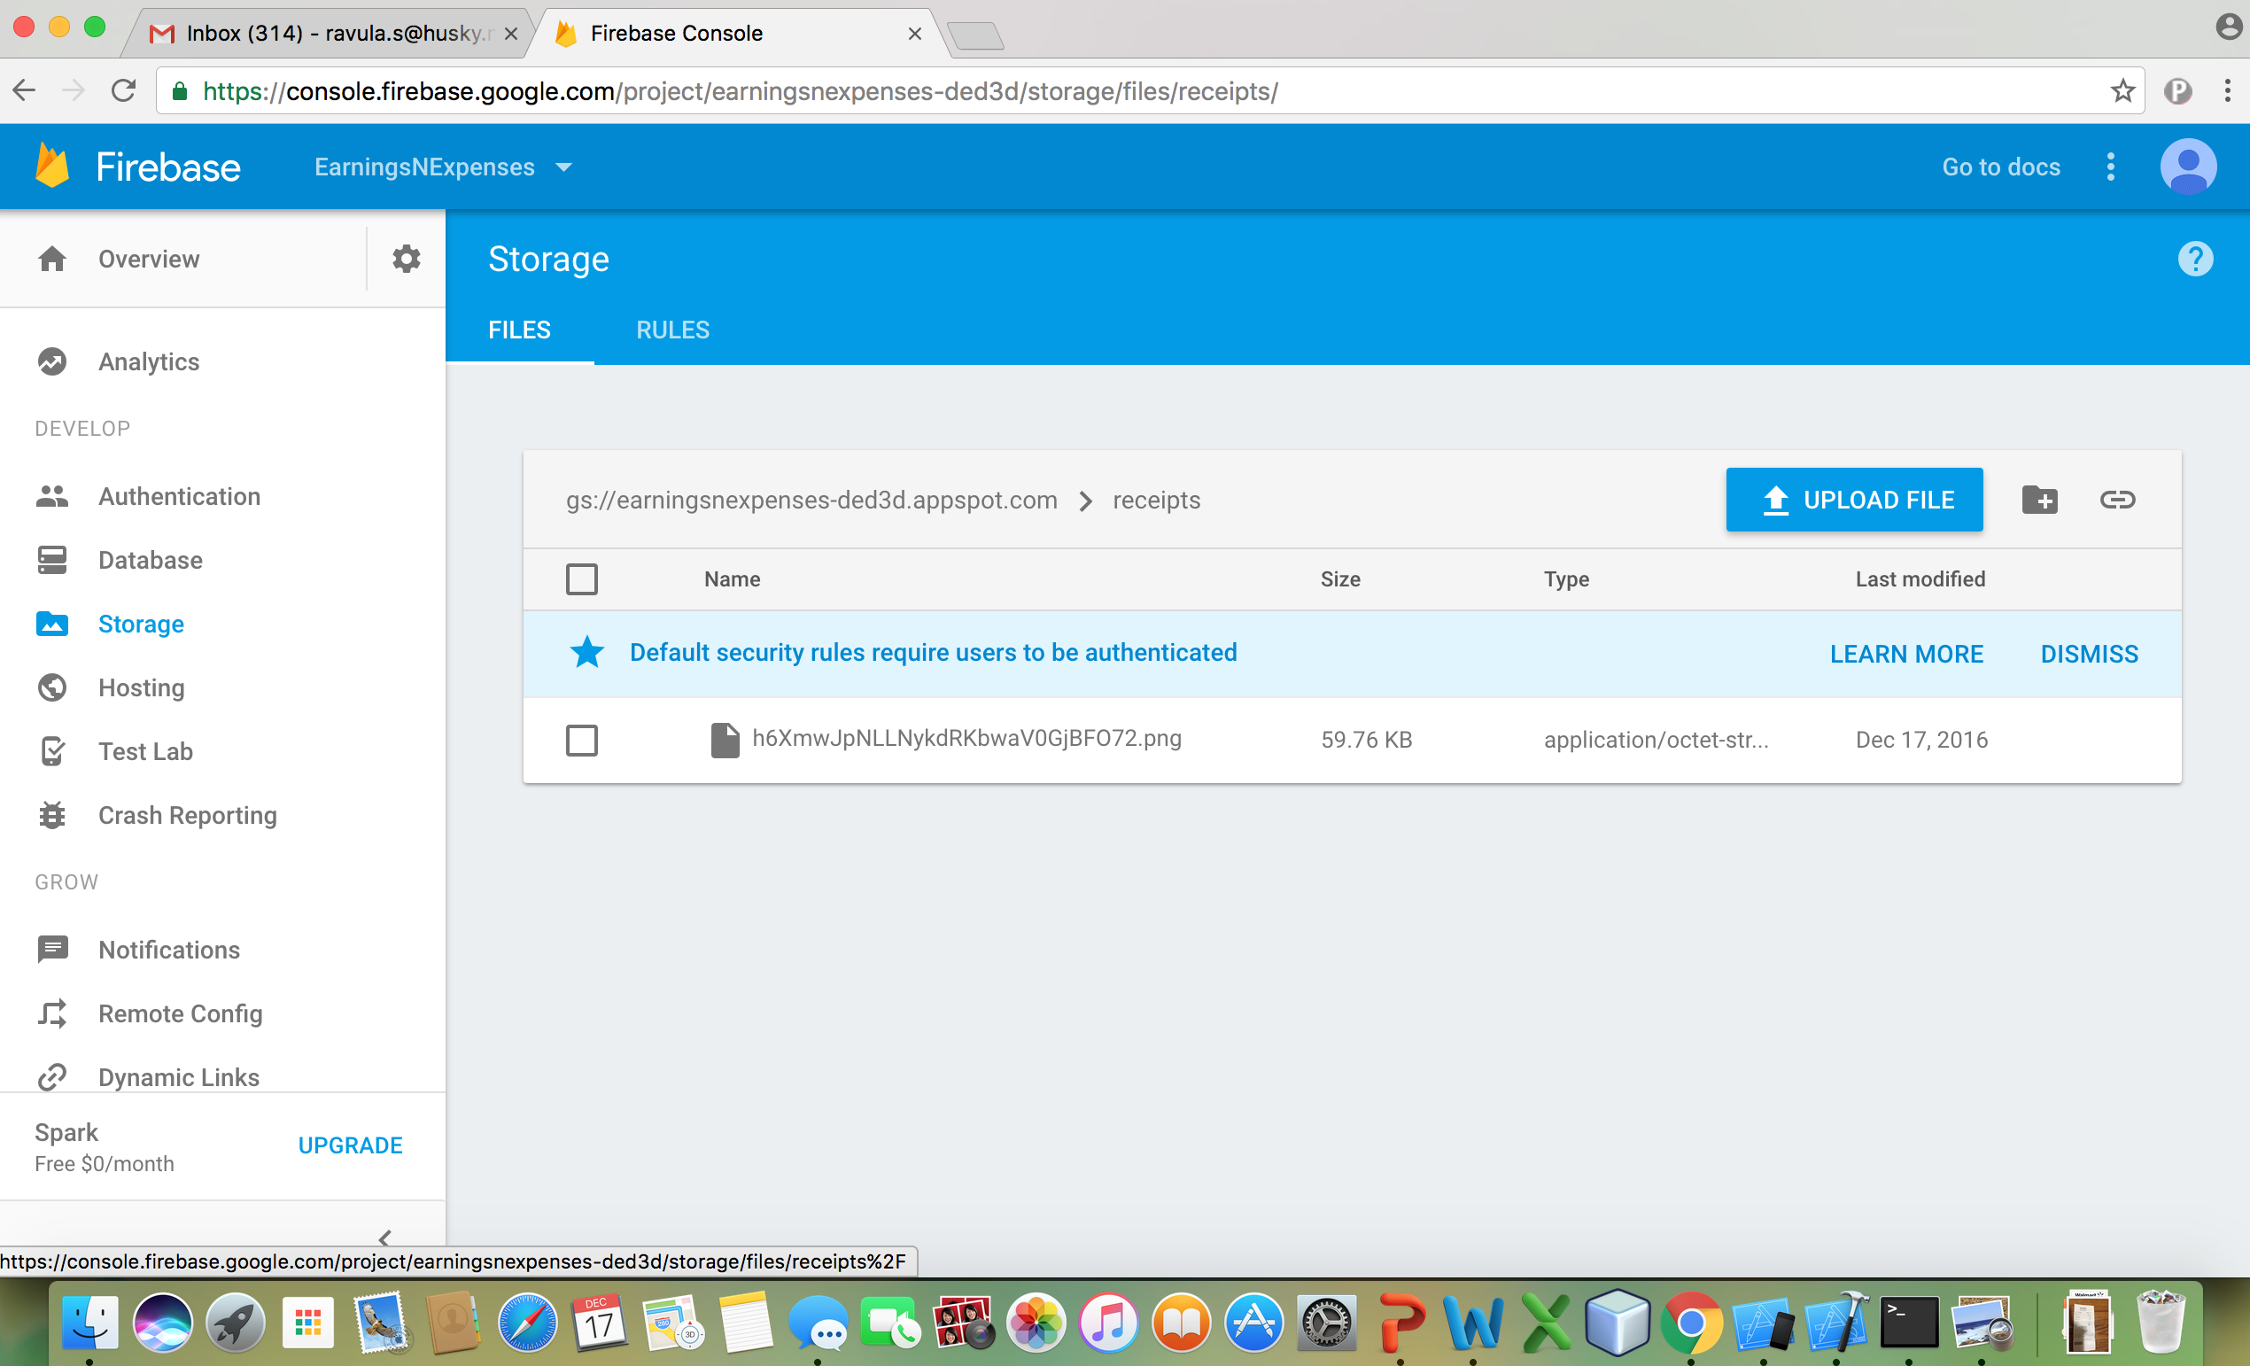

Profile pictures are stored under profilepics/

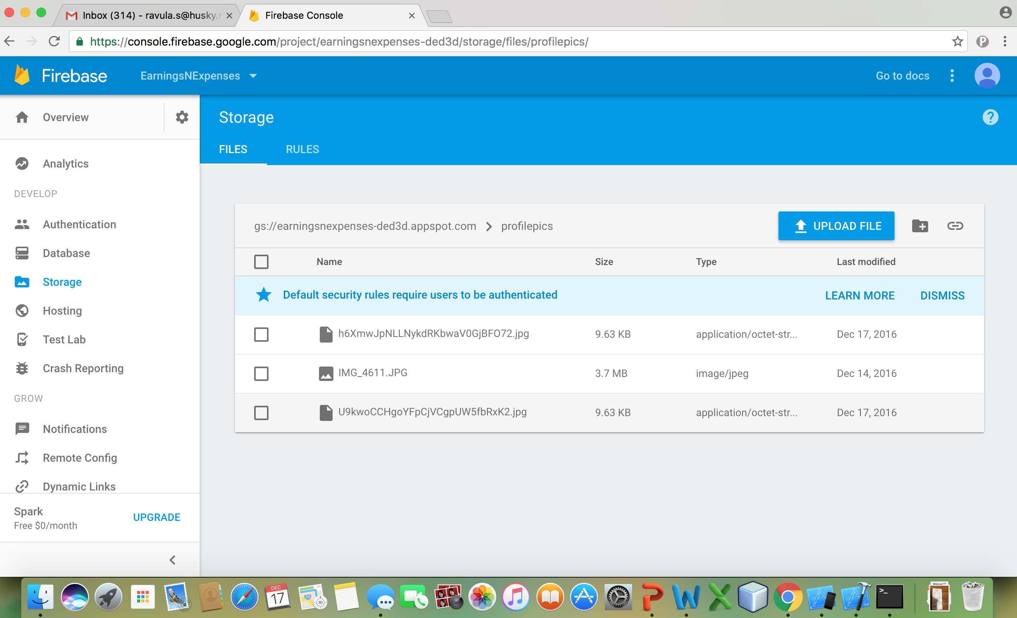

All the common pics are stored in the commonpics/

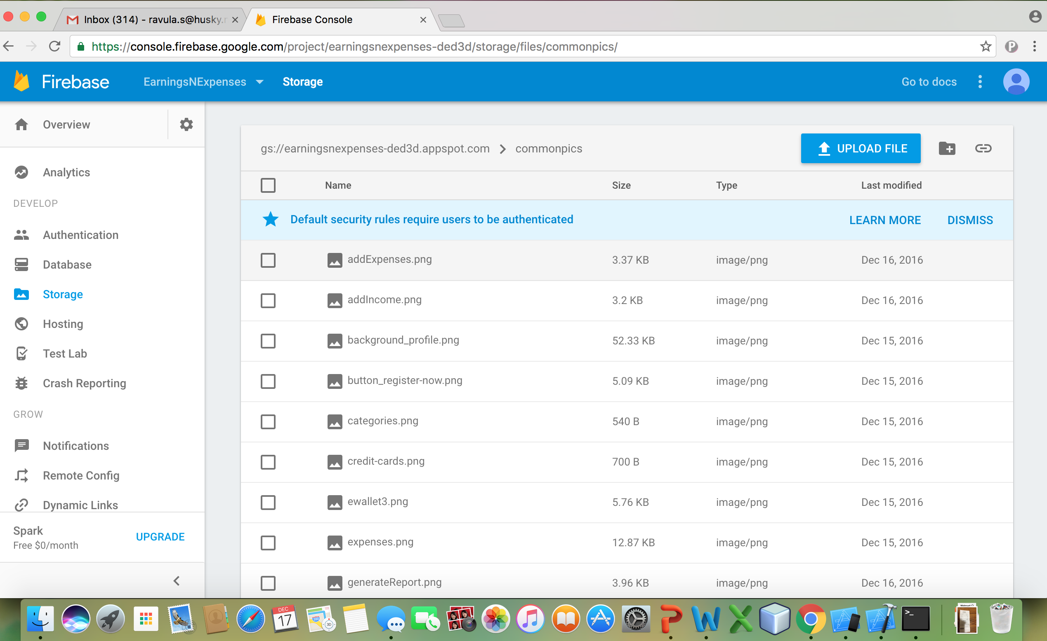

**Future Enhancements:**

* Generate Report the Year, Month and by selecting dates
* User can share the report via Mail
* Integrate with the other business apps like “Concur”
* Make the application more customizable by allowing the user to add categories similar to Earnings.
* User Analytics to suggest ways to save more money effectively and identify the category, which has more expenses.